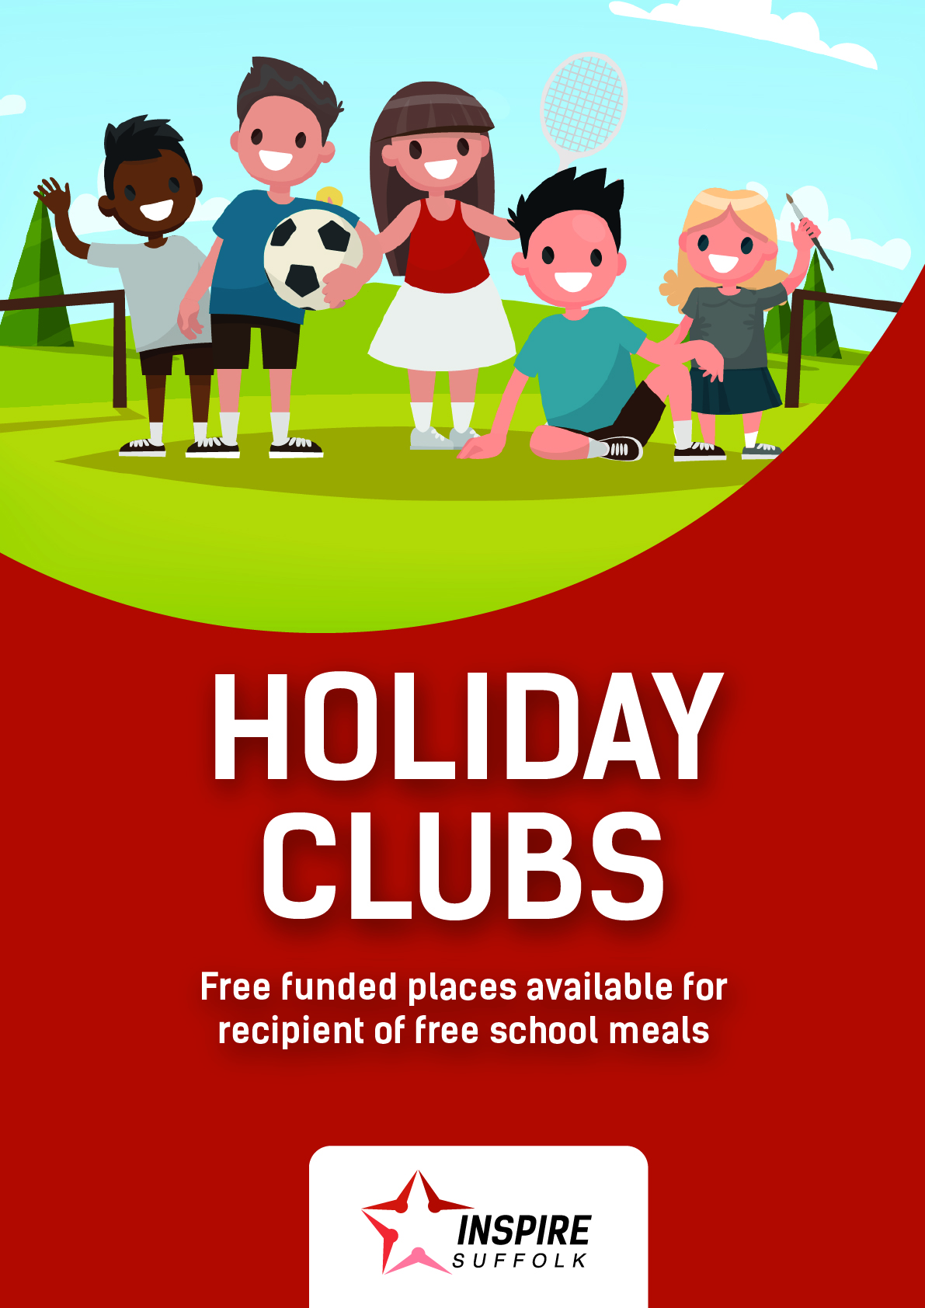

Is my child the right age to come to your clubs?
Our clubs are available for school-going children, aged 4 – 14.

What activities will my child be doing?
We have four different camps to choose from, full of learning experiences and school holiday fun:
Reach for the Stars (Reception and KS1): Supporting the development of children in early years education. This group is available at all of our clubs!
Shooting Stars (KS2): Full of games, sports, and high-octane fun, you can enjoy this group at any one of our locations.
All-Stars (KS2): The perfect choice for children who are creative and love to perform! Available at all of our venues this summer.
Rising Stars (KS3): Creating the leaders of tomorrow. Discover what it’s like to be an Inspire Suffolk Coach, exclusively at our Ipswich venue.
Designed by our qualified staff, each club is jam-packed with fun activities to keep your child active and engaged this school holiday. Our new clubs not only provide an unforgettable experience, but they also focus on developing the life skills your child needs.
Our activities support your child’s learning while keeping them happy, healthy, and engaged. Whether it’s cake making, football training or Lego creations, there’s always something exciting to be a part of!

Where will the clubs be running?
This summer holiday we will be running our holiday clubs in the following locations:
- IPSWICH: Inspire Suffolk, Lindbergh Road, Ipswich IP3 9QX
- FELIXSTOWE: Felixstowe and Walton United Football Club, 4A Dellwood Ave, Felixstowe IP11 9HT
- LOWESTOFT: Dell Primary School, Dell Road, Oulton Broad, Lowestoft, NR33 9NU
Benjamin Britten School, Blyford Rd, Lowestoft, NR32 4PZ
- WOODBRIDGE: Melton St Audrys Club, Lodge Farm Lane, Melton, Woodbridge, IP12 1QS

Is there any financial assistance available?
This summer, we will be delivering the government’s Holiday Activities and Food Programme to provide free lunches and holiday club places to children who are eligible for Pupil Premium.
If your child receives free school lunches, you may be eligible for free childcare this summer. To enquire, please call our office on 01473 353194.
The scheme, funded by the Department of Education and managed by Suffolk County Council, aims to tackle health inequalities by offering children opportunities to socialise and take part in enrichment without the barrier of cost. We are also working with East Suffolk Council to deliver the programme.

How do I know if I’m eligible for funded places?
Our free, funded places are available to children who receive free school meals, known as ‘Pupil Premium’. There are a couple of exceptions - for example, children in Reception can only access a place if they’d continue to get free meals in Year 1 – but we would be happy to check your eligibility. We want to make sure the free places are as easy to access as possible.

What does a funded place include?
As part of their funded place, children will take part in the same great holiday club activities as their peers and will also be provided with a free packed lunch containing a sandwich, crisps, fruit and drink!
You can book up to 15 x Standard Days (8.30am – 3.30pm) on our club free of charge if you are eligible.

How do I book a place for my child?
Free, funded places can be booked over the phone by calling 01473 353194. We will need to take some details about your child, such as any relevant medical information and allergies, so please allow 30 minutes for the call.
Our office hours are 8.30am – 5.30pm on Monday – Friday.
Paid for places can be booked on our website by visiting https://inspiresuffolk.org.uk/courses/holiday-clubs/ and following the steps below:
- Add the selected tickets to basket and proceed to checkout
- Create or select an attendee
- Add required details for each attendee
- Fill out the additional questions including their Star Group
- Proceed to payment
At present, we will not be able to accept cash payment on the day or accommodate any on the day bookings for the health and safety of the children, staff and visitors on our premises.

